Day 6 (31 May 2025)
112552596 - vsisukhw - Sukhwinder Singh

Task 1
Regular expression (regex)

Regular expressions (regex) in Linux are like patterns used for searching, matching, and manipulating text. They are commonly used with tools like grep, sed, awk, find, etc.

🔹 Basic Regular Expression Syntax (Linux)

. (dot)
Matches any single character except a newline.
Example: a.c matches abc, acc, a-c

* (asterisk)
Matches 0 or more occurrences of the previous character.
Example: lo* matches l, lo, loo, looo

+ (plus)
Matches 1 or more occurrences of the previous character.
Example: lo+ matches lo, loo, but not just l

? (question mark)
Matches 0 or 1 occurrence of the previous character.
Example: lo? matches l or lo

[] (square brackets)
Matches any one character inside the brackets.
Example: [abc] matches a, b, or c

[^] (caret inside brackets)
Matches any one character NOT inside the brackets.
Example: [^0-9] matches any character except digits

^ (caret)
Matches the start of a line.
Example: ^abc matches lines that start with abc

$ (dollar sign)
Matches the end of a line.
Example: abc$ matches lines that end with abc

| (pipe)
Acts as a logical OR.
Example: foo|bar matches foo or bar

() (parentheses)
Used to group expressions or capture groups.
Example: (ab)+ matches ab, abab, ababab

{n,m} (curly braces)
Matches at least n and at most m occurrences of the previous character.
Example: a{2,4} matches aa, aaa, or aaaa

Task 2
Linux OS and its Features

Main Features of Linux
- Open Source
  - The source code of Linux is freely available.
  - Anyone can view, modify, and distribute it.
  - Popular distributions: Ubuntu, Fedora, Debian, CentOS, Arch, etc.
- Free to Use
  - Most Linux distributions are completely free.
  - No licensing fees (unlike Windows).
- Multi-user Capability
  - Multiple users can log in and use the system at the same time.
  - Each user has their own permissions and environment.
- Multitasking
  - Can run multiple tasks/processes at once without slowing down the system.
- Security
  - File permission structure (read, write, execute).
  - Regular updates, open-source transparency, and lower virus threats.
  - Tools like iptables, SELinux, and AppArmor for added protection.
- Portability
  - Linux can run on almost any hardware (phones, servers, supercomputers, Raspberry Pi).
- Stability and Reliability
  - Linux systems can run for years without rebooting.
  - Ideal for servers that need high uptime.
- Command-Line Interface (CLI)
  - Powerful terminal access for advanced control and automation.
  - Bash, Zsh, Fish are common shells.
- Modular Architecture
  - Linux follows a monolithic kernel but can load/unload components like device drivers dynamically.
- Support for Programming
- Supports almost all major programming languages (C, Python, Java, Shell, etc.).
- Built-in compilers and scripting tools.
- Package Management
- Software is installed and managed via package managers like apt, yum, dnf, pacman.
- Community Support
- Large and active community support through forums, GitHub, Stack Overflow, etc.
- File System Support
- Supports multiple file systems like ext4, XFS, Btrfs, NTFS, FAT32, etc.
- Networking Capabilities
- Linux is built for network tasks: servers, routers, firewalls, VPNs, etc.
- Customization
- Highly customizable (desktops, scripts, services).
- we can even build our own version of Linux using tools like Linux From Scratch (LFS).

Task 3
Kernel

The kernel is the core part of any operating system, including Linux. Its like bridge between computer's hardware and software.
It controls how everything works inside computer—but we can’t see it directly.

In Simple Words:
Imagine computer is a factory:
- The hardware (CPU, memory, hard drive) are the machines.
- The applications (browser, editor, games) are the workers.
- The kernel is like the manager that makes sure workers can use the machines properly—without fighting, crashing, or making a mess.
Task 4
Bash Full Form and Explanation

BASH stands for Bourne Again SHell
It is a command-line shell and scripting language used in most Linux distributions.
Bash is the default shell in most Linux systems. A shell is a program that takes commands from our keyboard and gives them to the operating system to execute.

Task 5
Difference b/w Linux and Windows

Linux is a free, open-source operating system that is secure, fast, and highly customizable. It’s mostly used by developers, tech users, and for servers. Windows, on the other hand, is a paid, closed-source system developed by Microsoft. It’s user-friendly, widely used in homes and offices, and supports most commercial software and games.
Linux is more secure and efficient, while Windows is easier for beginners and better for general use.

Task 6
Basic Components of Linux

Basic Components of Linux (Brief)
- Kernel
The core part of Linux that manages hardware, memory, and processes.
- System Libraries
Help programs communicate with the kernel by providing reusable functions.
- System Utilities
Basic commands and tools to perform common tasks like file management.
- Shell
The interface where users type commands; it passes these commands to the kernel.
- Hardware
Physical devices like CPU, memory, and storage that Linux controls through the kernel.
- Applications
Programs that users run, such as browsers and editors, which use the shell and libraries.
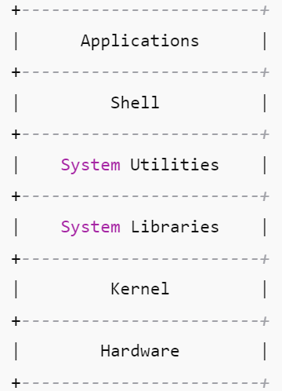

Task 7
Is it legal to edit Kernal ? When we have to edit in case?

Yes, it is completely legal to edit the Linux kernel!
Linux is open-source software released under the GNU General Public License (GPL). This license allows anyone to view, modify, and redistribute the kernel’s source code freely, as long as they follow the GPL terms (like sharing modifications under the same license).

When would we want to edit the kernel?
We might want to edit or customize the Linux kernel in cases like:
- Adding support for new hardware that isn’t recognized by the current kernel.
- Improving performance or fixing bugs specific to our hardware or use case.
- Removing unneeded features to create a smaller, faster, or more secure kernel.
- Developing new kernel features or modules for specialized tasks.
- Experimenting or learning how an OS works at the core level.

Task 8
What is LILO?

LILO stands for Linux Loader.
It is a boot loader for Linux — a small program that loads the Linux operating system into memory when the computer starts.
Task 9
What is Shell, how many shells are there and what are they?

A shell is a program that acts as an interface between the user and the operating system (kernel).
It lets us to enter commands that the system can understand and execute.

Types of Shells in Linux:
There are many types of shells.

1. Bash (Bourne Again SHell)
- Most common and default on many Linux systems
- Easy to use, supports scripting
- Command: /bin/bash

2. Sh (Bourne Shell)
- The original Unix shell
- Simpler and older than Bash
- Command: /bin/sh

3. Ksh (Korn Shell)
- Combines features of Bourne and C shells
- Good for scripting and programming
- Command: /bin/ksh

4. Csh (C Shell)
- Syntax similar to C programming
- Has features like aliases and command history
- Command: /bin/csh

5. Tcsh
- An enhanced version of C Shell
- Includes improvements like auto-completion
- Command: /bin/tcsh

6. Zsh (Z Shell)
- Powerful and customizable
- Has features of Bash, Ksh, and Tcsh
- Popular for its themes and plugins (e.g., Oh My Zsh)
- Command: /bin/zsh

Task 10
What is Swap Space?

Swap space is a special area on the hard disk that the operating system uses as virtual memory when RAM is full.
In simple words,
We can imagine that RAM is our desk. When it's full of books (data), we move some to a nearby shelf (swap space) to make room.
Task 11
What is Mount, how do we mount and unmount file system in Linux?

In Linux, mounting means making a storage device (like USB, hard drive, CD, etc.) accessible to the system by attaching it to a directory (called a mount point).
Once mounted, we can read or write files from that device as if it’s part of our file system.

For mounting:
sudo mount /dev/sdX1 /mnt
For un-mounting:
sudo umount /mnt

Task 12
What is chmod command and how to use it?

chmod stands for "change mode".
It is used to change the permissions (read, write, execute) of a file or directory in Linux.

Linux systems control who can:
- Read a file (r)
- Write or modify a file (w)
- Execute a file or script (x)
chmod lets we set or modify these permissions for:
- User (u) – the file owner
- Group (g) – users in the file’s group
- Others (o) – everyone else
How to Use chmod:
Each permission has a number:
- Read = 4
- Write = 2
- Execute = 1
They are added together:
- Read + Write + Execute = 7
- Read + Execute = 5, etc.
Format: chmod XYZ filename
Where:
- X = User permission
- Y = Group permission
- Z = Others permission
Example:
- chmod 755 filename
Here,
User: 7 (r+w+x), Group: 5 (r+x), Others: 5 (r+x)
- chmod 644 myfile.txt
Here,
User: read/write,
Group: read,
Others: read

Task 13
Can we add new user , how to add it ?
Yes , we can add new user, following are the screenshot:
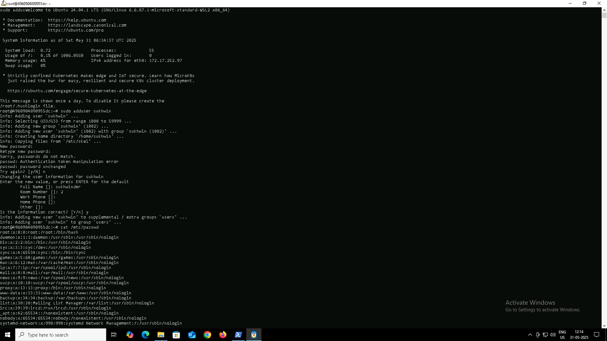

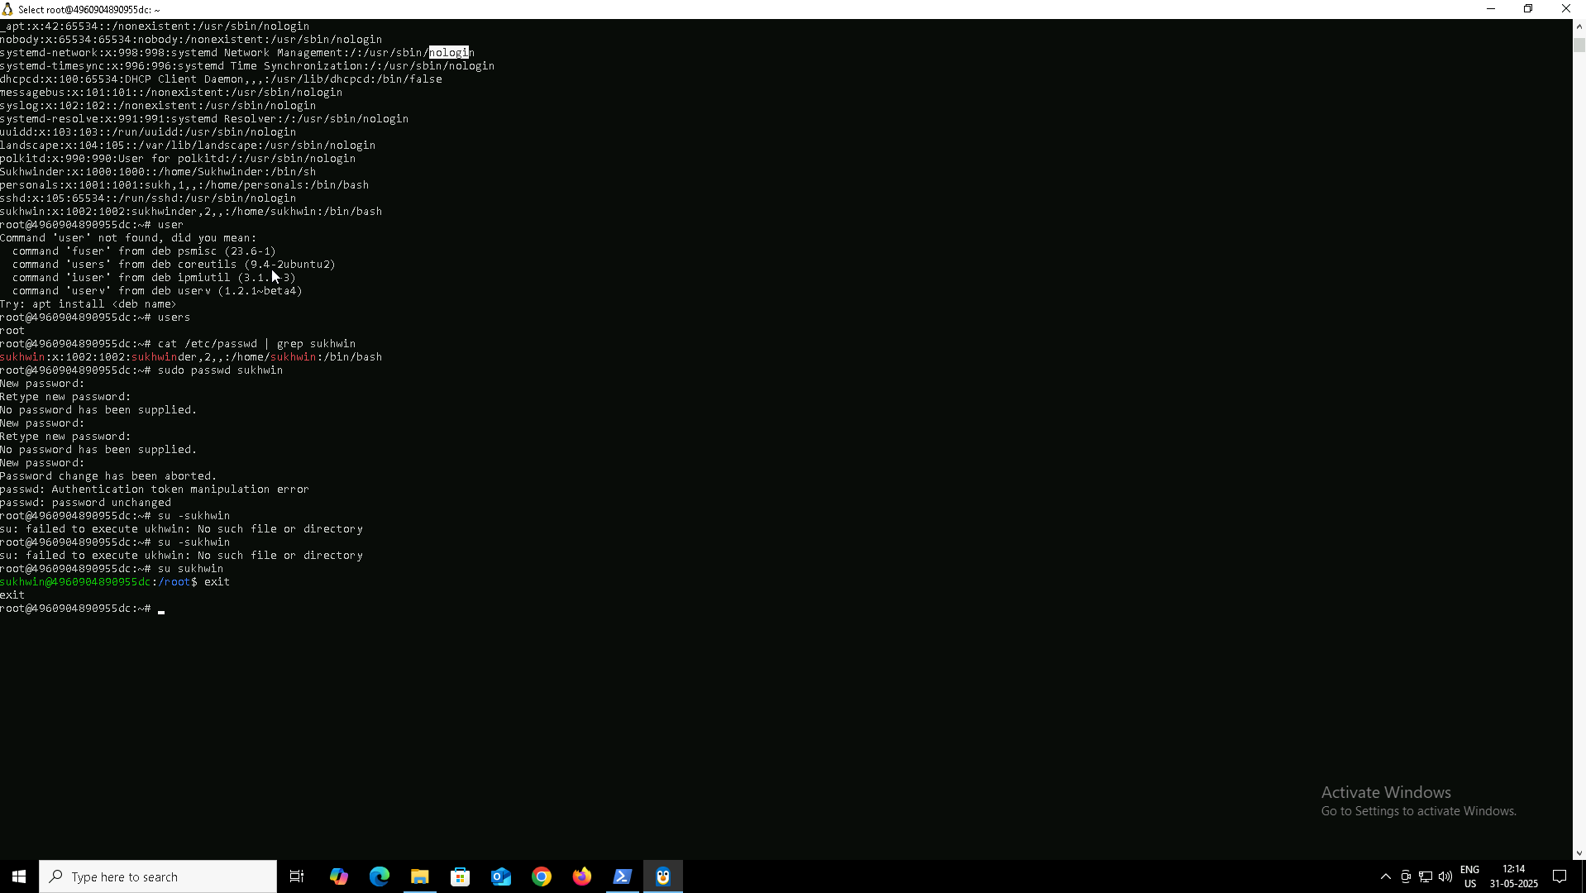

Task 14
Can we change password of user ,how to do it?

Yes , we can change password of user, following are the screenshot:

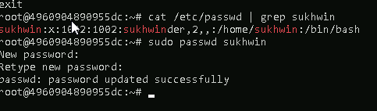

Task 15
Differnce b/w Process and Thread

Process:
- Independent program running with its own memory.
- Heavyweight, slower to create.
- Crashes don’t affect other processes.

Thread:
- A smaller unit within a process sharing the same memory.
- Lightweight, faster to create.
- Crashes may affect the entire process.

In short, a process is like a full program, and threads are tasks inside that program running simultaneously.

Task 16
Linux grep Commands

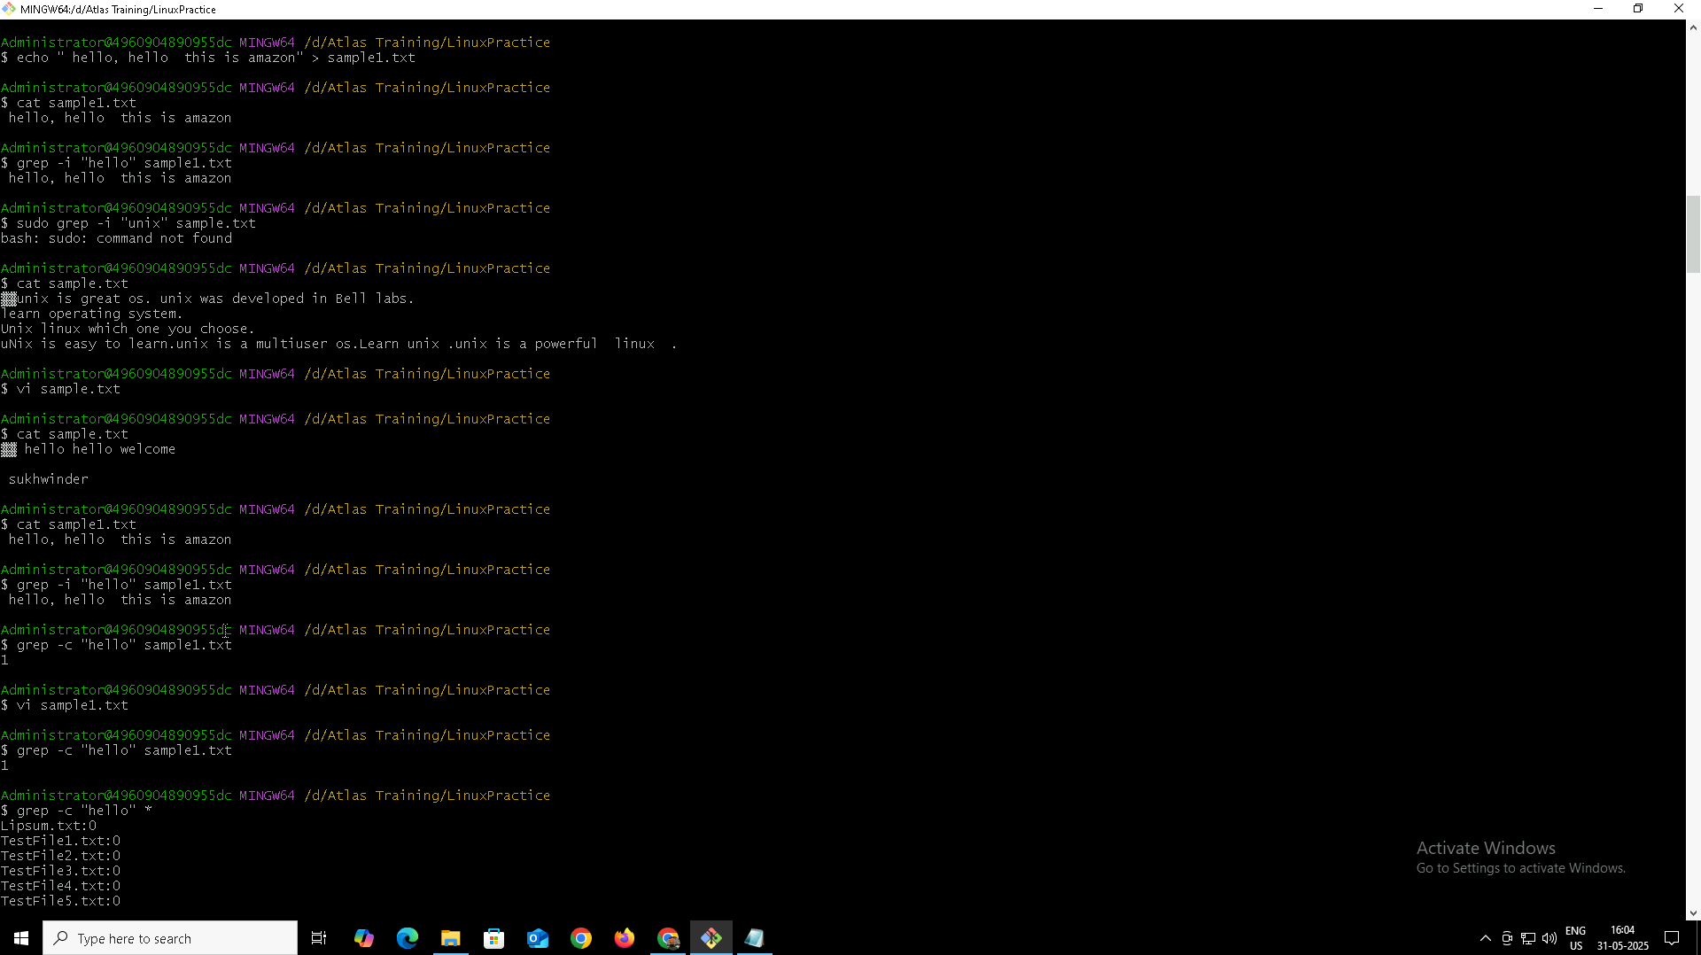

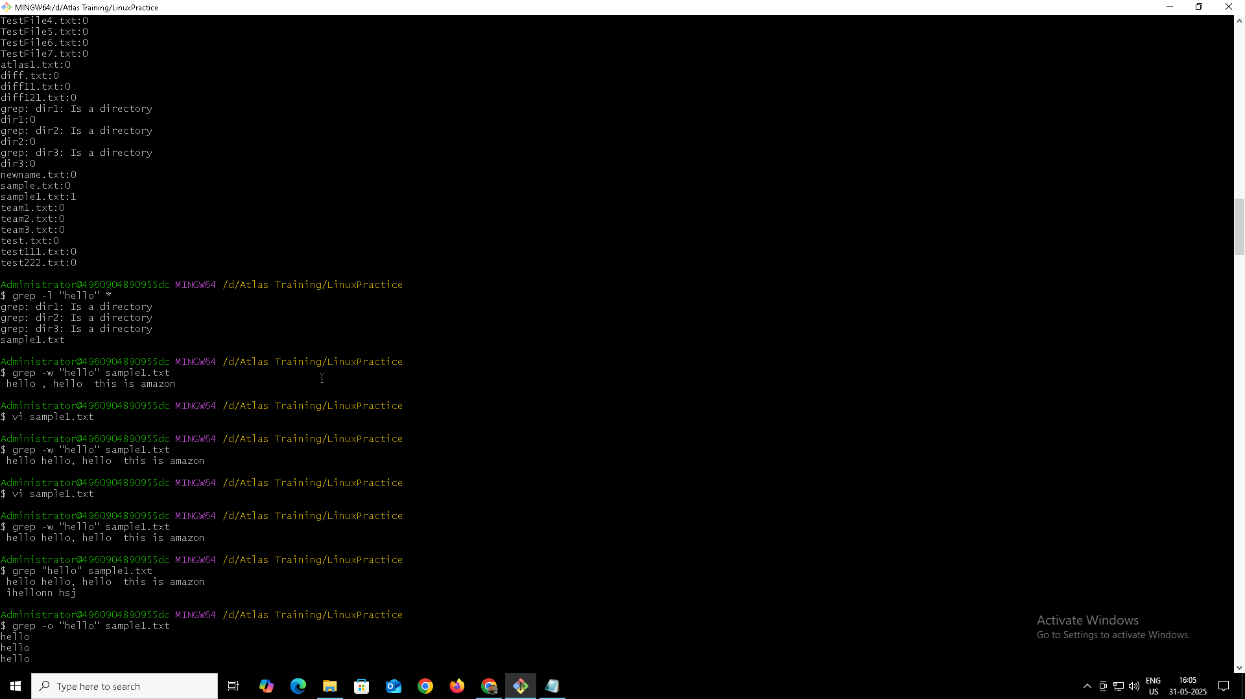

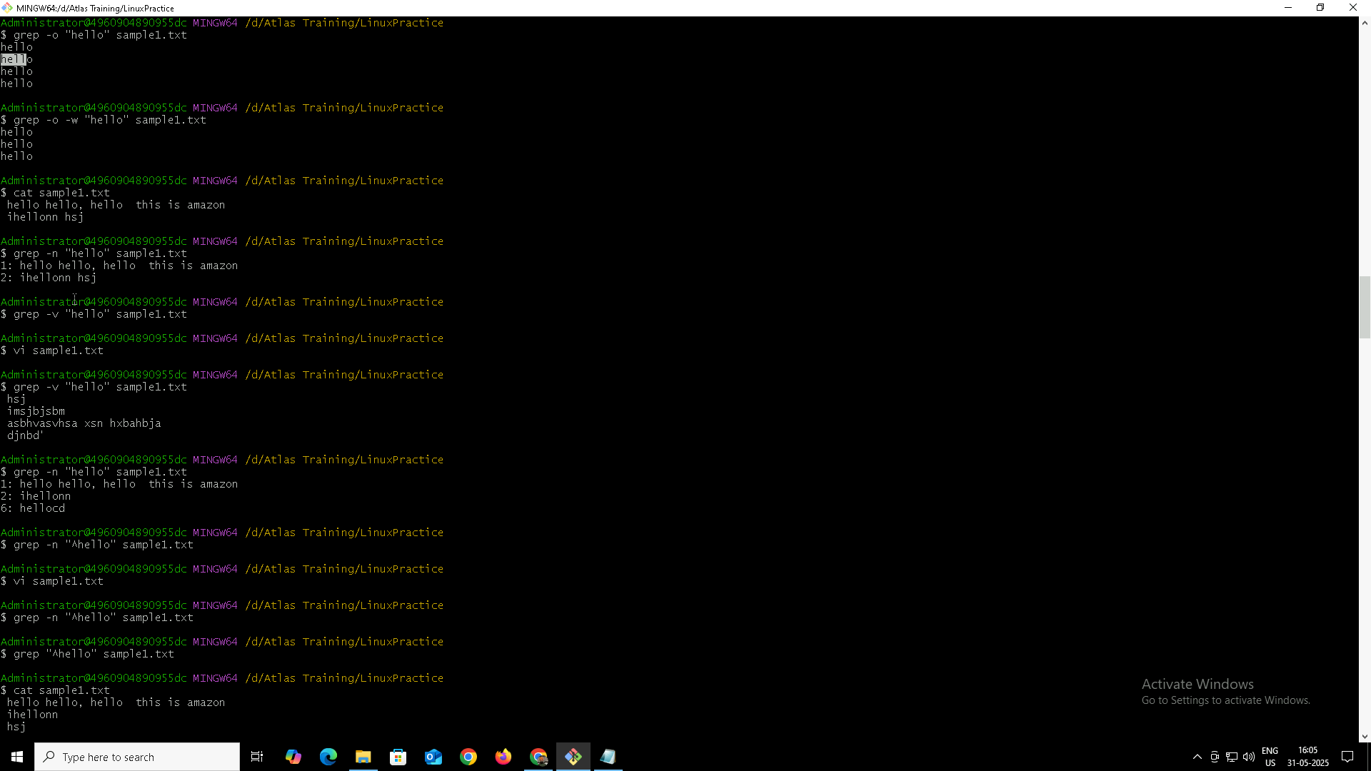

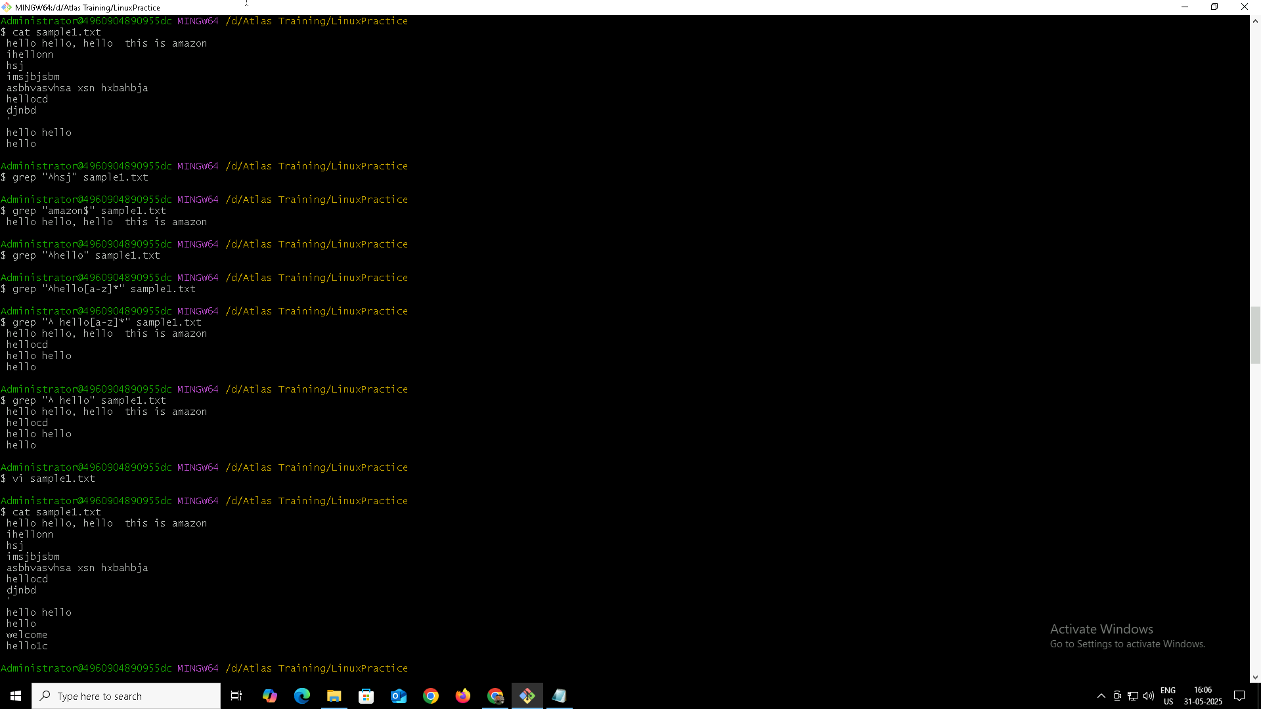

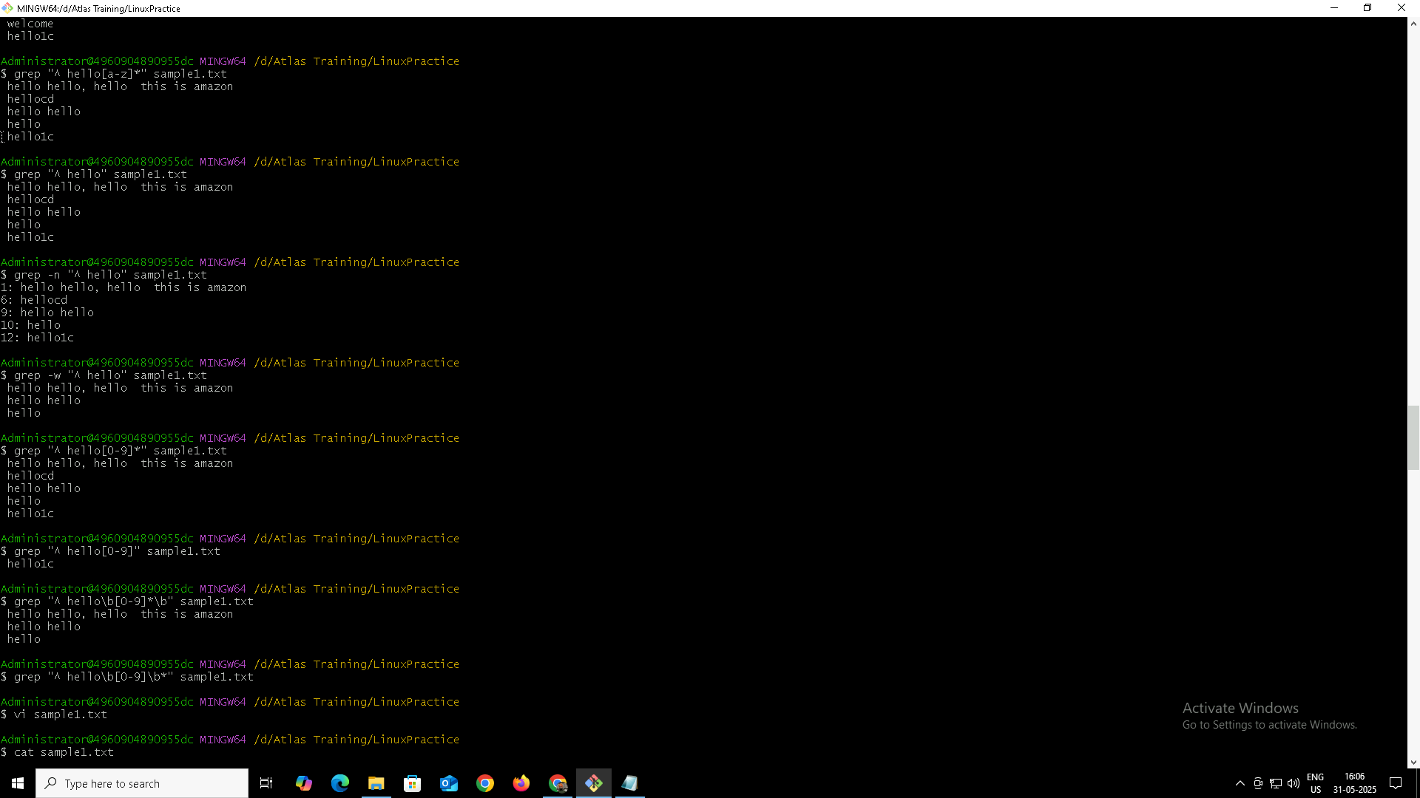

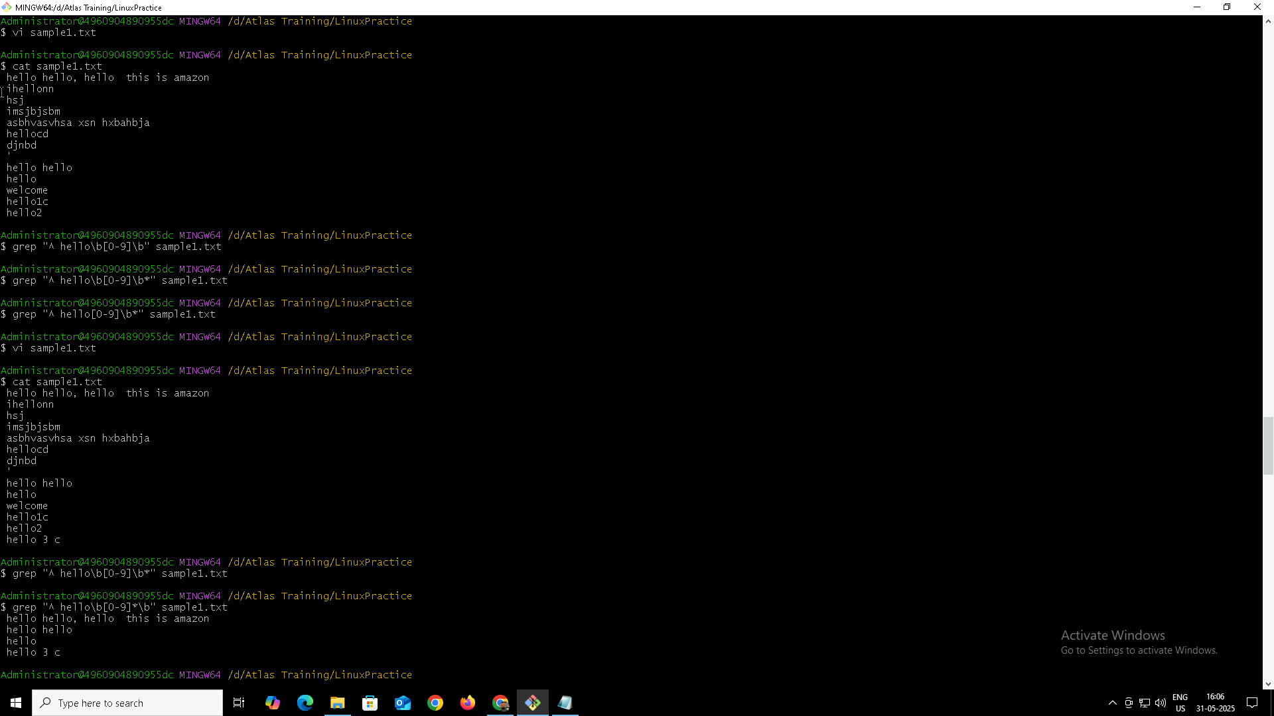

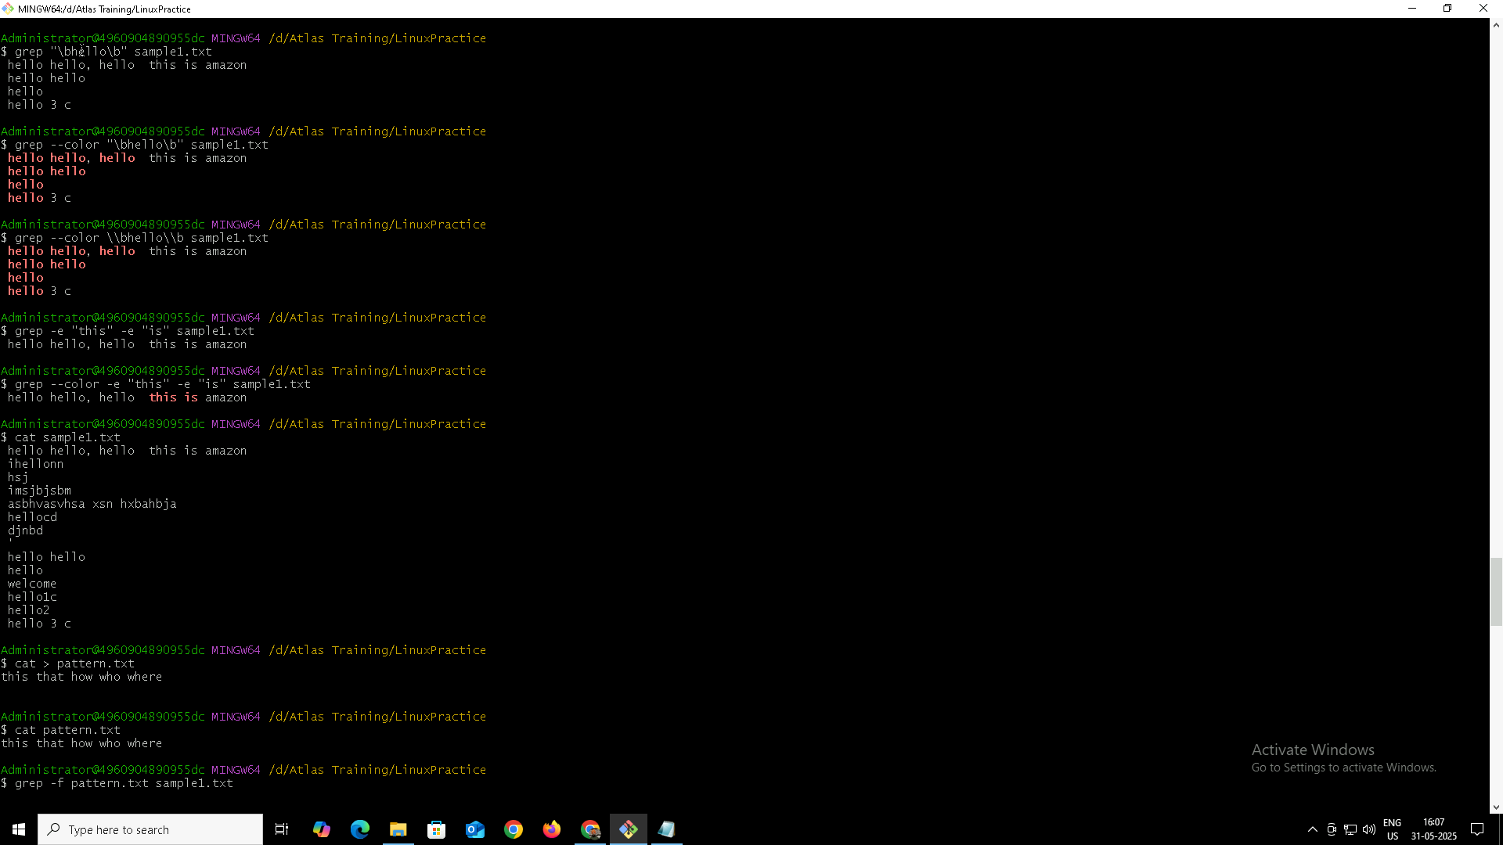

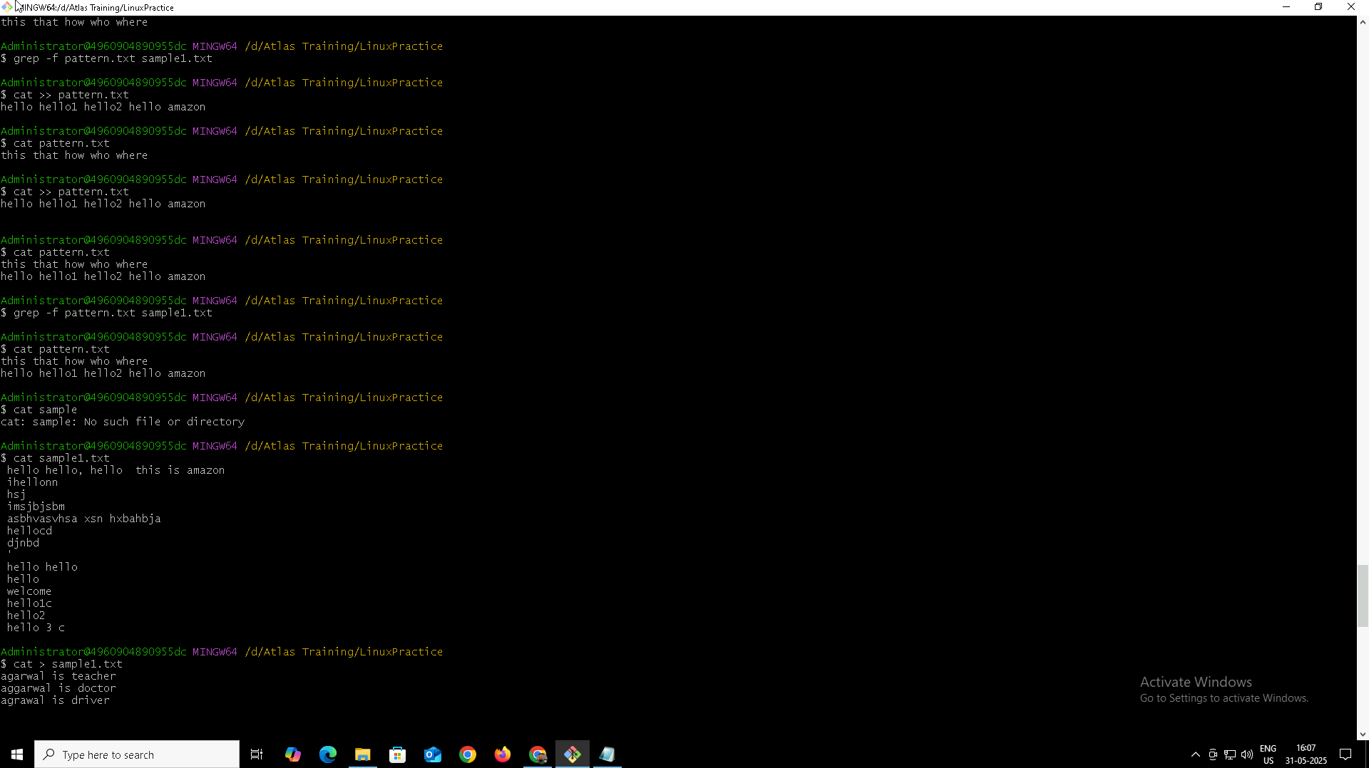

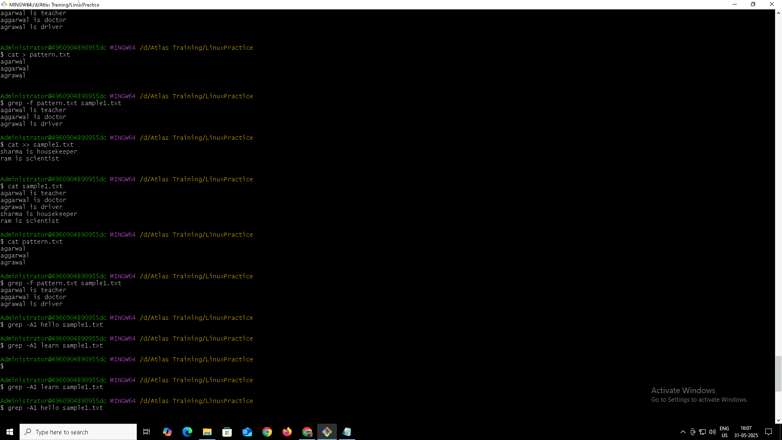
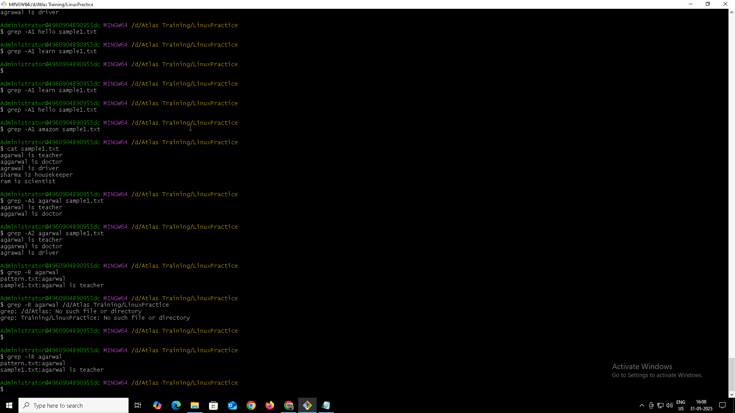
Task 17
Awk Commands
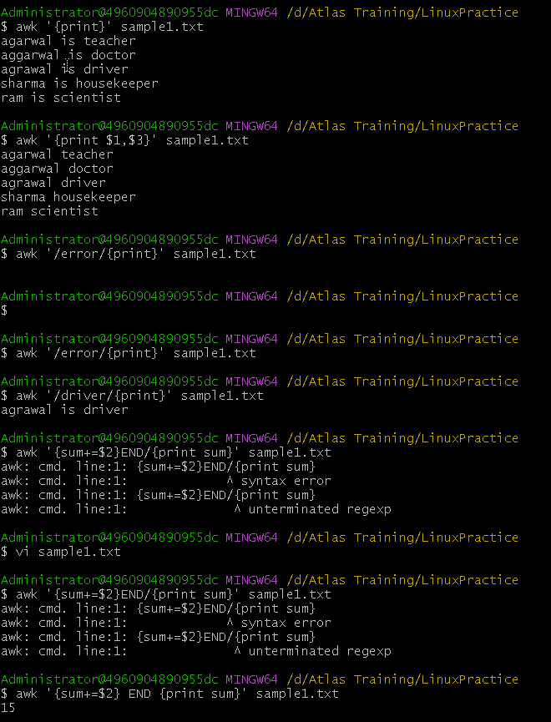

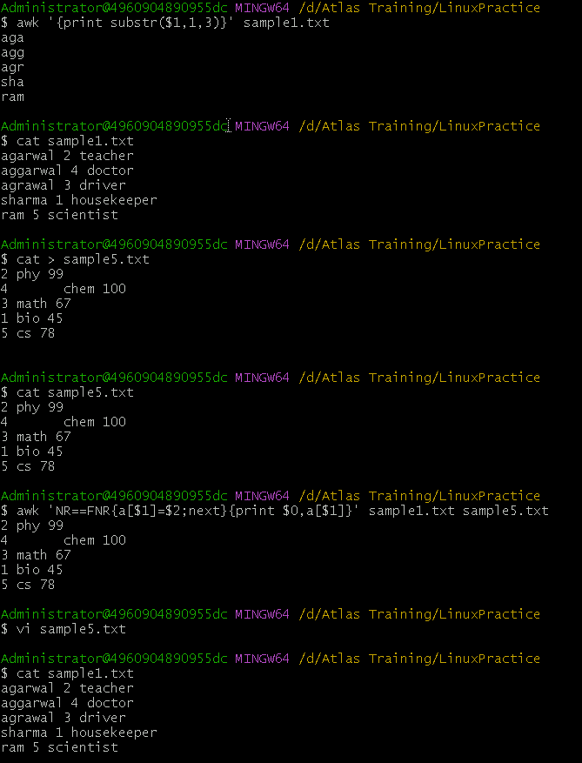

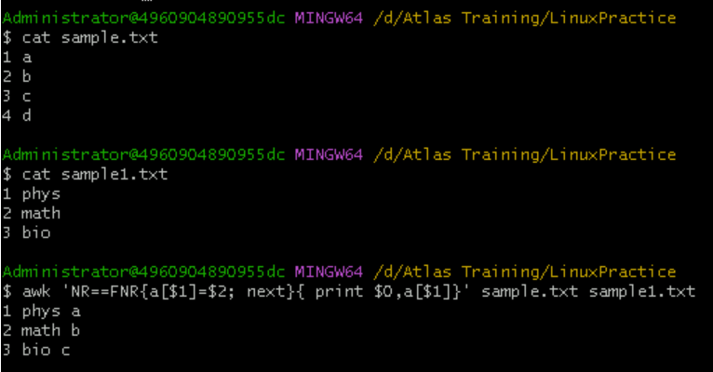
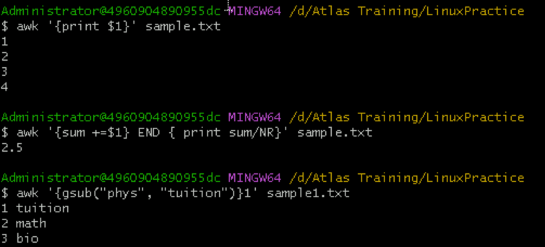
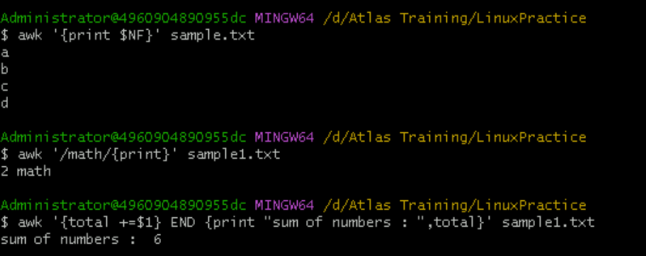

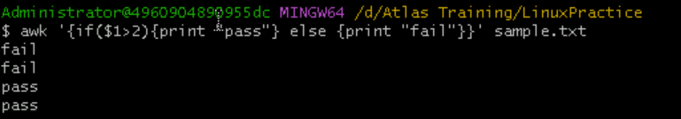
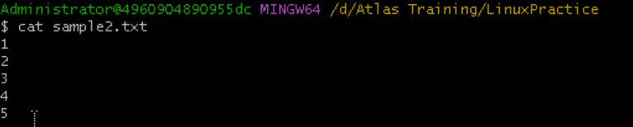
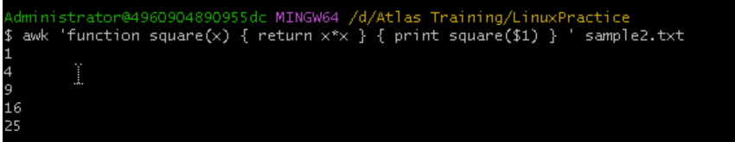

Task 18
How to check file access permission in Linux

To check file access permissions in Linux, we can use the ls -l command. It displays the permissions, ownership, and other details of files and directories.
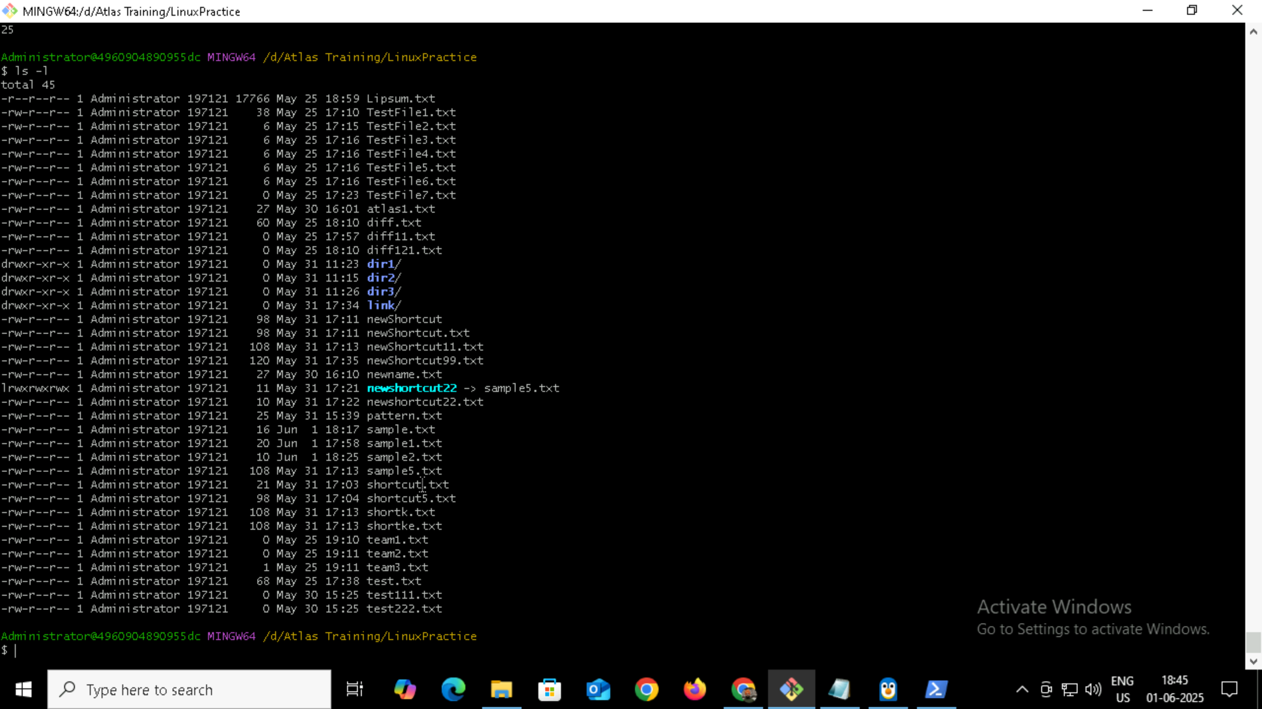

Task 19
Default Permission for a new file

When you create a new file, the default permission is usually:
-rw-r--r–
Which means:
- User (owner): read & write (rw-)
- Group: read only (r--)
- Others: read only (r--)
By default, new files are not executable, because:
- Most files are documents, scripts, configs — not programs.
- We must manually add execute permission if needed
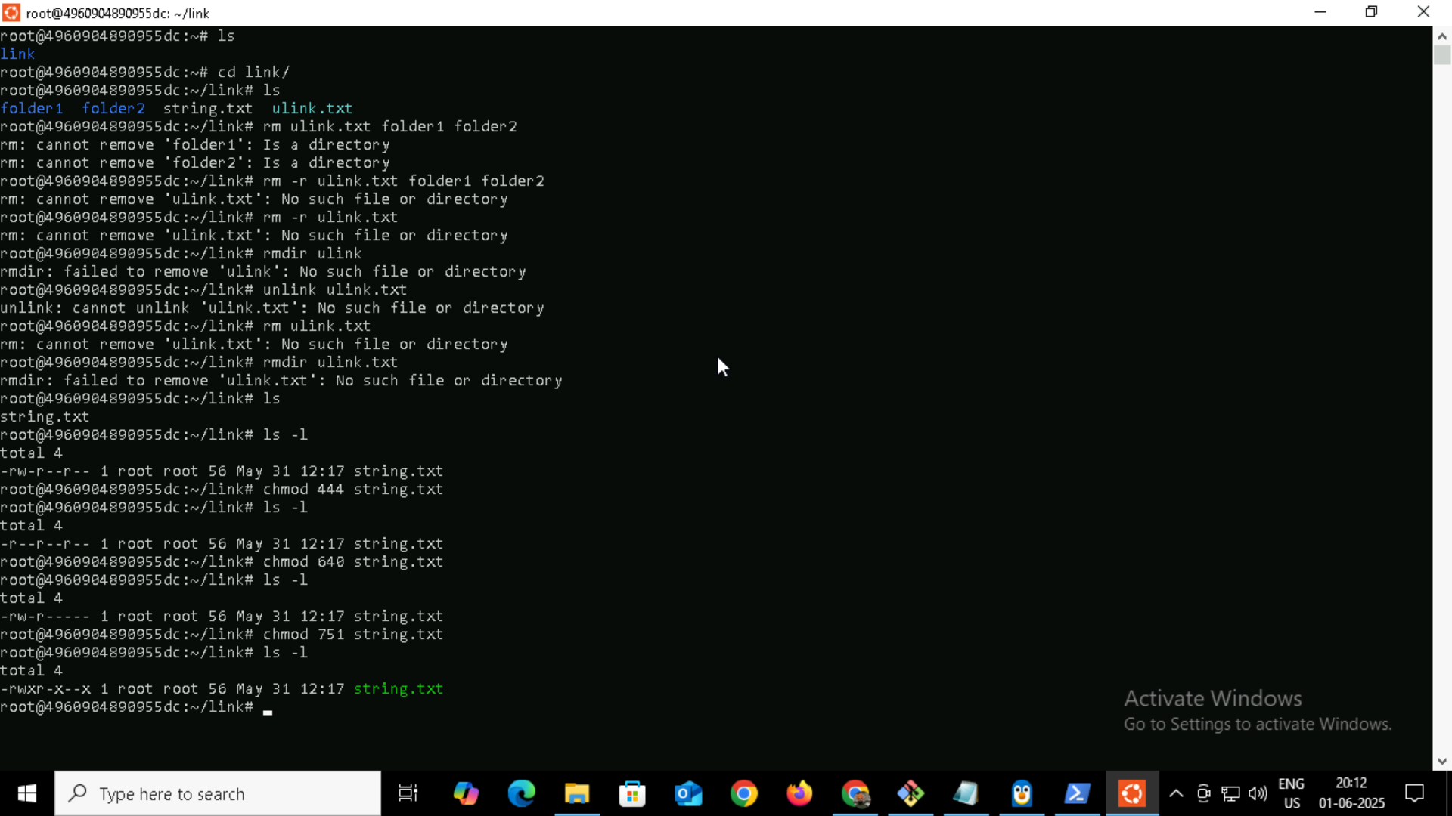

Task 20
Command to change the permission to read only for the owner, group and all other users

To change the permission of a file so that only read access is allowed for:
- the owner (user),
- the group, and
- others (everyone else),
We can use the chmod command like this:
chmod 444 filename



Task 21
Can you change the file permissions to match the following:
- owner: Read and Write
- group: Read
- other: no permissions (None)

Yes, We can set those exact permissions using the chmod command.

Required Permissions:
- Owner: Read & Write → rw- → 6
- Group: Read only → r-- → 4
- Others: No permission → --- → 0

Command:
chmod 640 filename

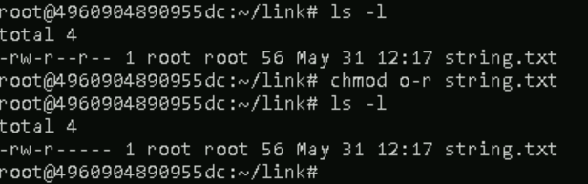

Task 22
Command for changing the file permissions to -rw-r-----?

Breakdown of -rw-r-----:

Owner Read + Write (rw-) 4+2
Group Read only (r--) 4
Others No permission (---) 0

So chmod 640 = 6 (owner) + 4 (group) + 0 (others)

And Command will be :
chmod 640 filename



Task 23
Can you change the file permissions to match the following:
- owner: Read, Write and Execute
- group: Read and Execute
- other: Execute

To set the file permissions as described:
- Owner: Read, Write, Execute → rwx → 7
- Group: Read, Execute → r-x → 5
- Others: Execute only → --x → 1

Command : chmod 751 filename
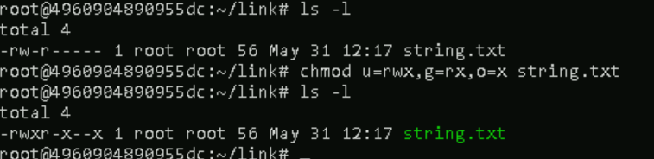

Task 24
Command for changing the file permissions to -rwxr-x--x?

Breakdown of -rwxr-x--x:

Owner Read + Write + Execute(rwx) 4+2+1
Group Read + Execute (r-x) 4+1
Others Execute Only (--x) 1

So chmod 640 = 7 (owner) + 5 (group) + 1 (others)

And Command will be :
chmod 751 filename



Task 25
What “chown -c master file1.txt” command will do?

It will :

Change the ownership of file1.txt to the user master, and

Display a message only if a change was made, because of the -c (--changes) flag.

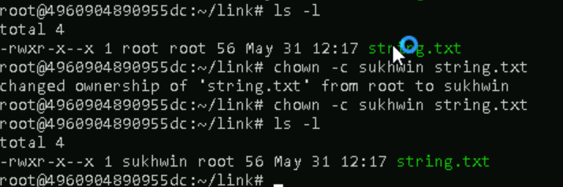

Task 26
What is a Process?

A process is an instance of a program that is currently being executed.

In simple terms:
- When you run a command or program, Linux creates a process.
- It has its own memory, unique Process ID (PID), and runs independently.

Task 27 and Task 28
Command to check foreground process and background process and list all the running processes?

Commands to check foreground and background processes in Linux:

1. Foreground Process:
- A foreground process is one that is currently attached to the terminal and actively running.
sleep 30

This will run sleep in the foreground — and we won't be able to type in the terminal until it finishes or you stop it.

2. Background Process:
- We can start a process in the background by appending &:
sleep 60 &

This starts sleep in the background, and the shell will show a job ID and PID.

Ps and ps aux

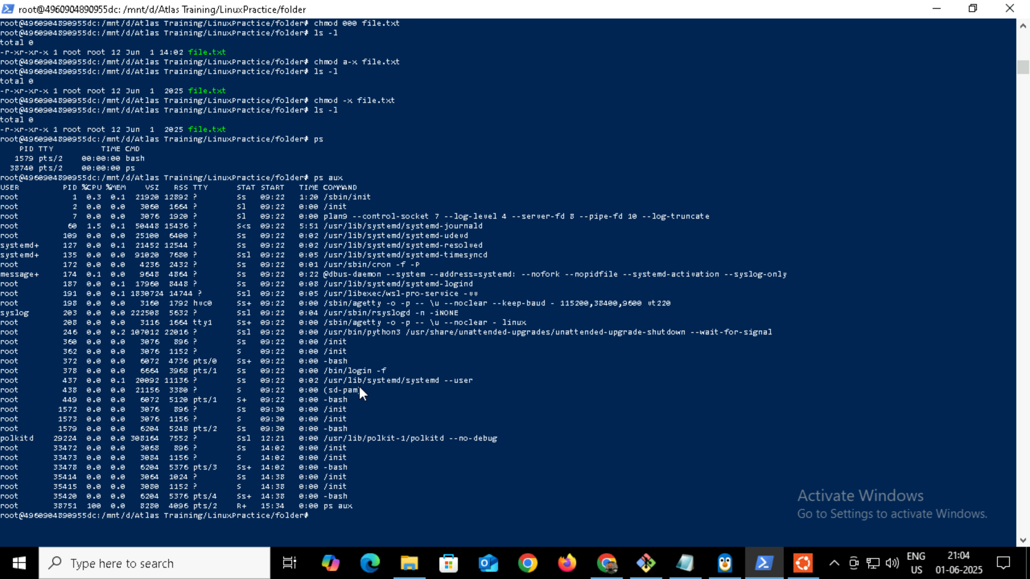

Task 29
What will ps -f command do ?
It is used to display currently running processes in a full-format listing (more detailed than the default).
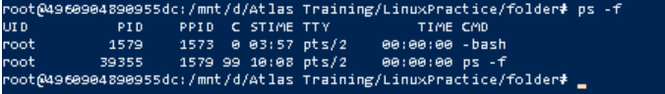

Task 30
Creating a variable Name and Id with our name

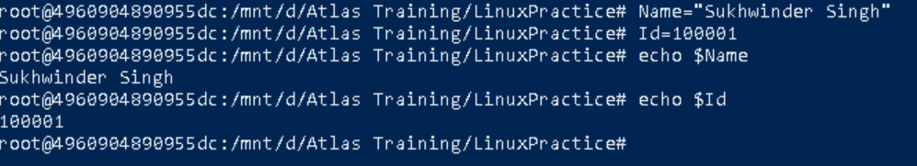

Task 31
Making the above variable readonly

Task 32
Unset or delete the variable and specify the reason to print empty line.

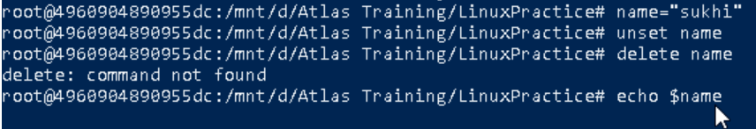

Empty line comes after unsetting and echoing the same variable(name).

Because :
- unset name removes the variable name from the shell's environment.
- So when we do echo $name, there's nothing to expand, resulting in no output (just a blank line).

Task 33 and Task 34
Try to add a list of friend’s names in an array and print it and can we print the list at once in an array

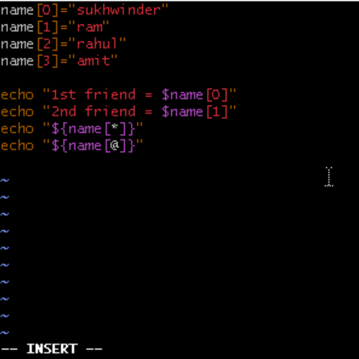
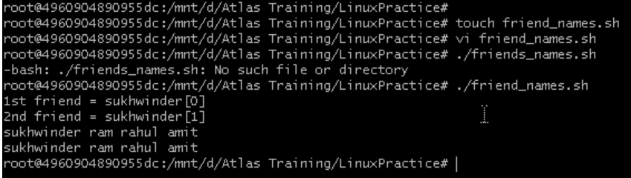

Task 35
What’s the output of the below snippet:

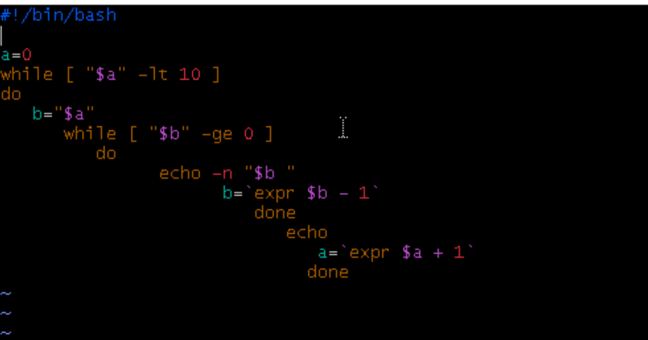

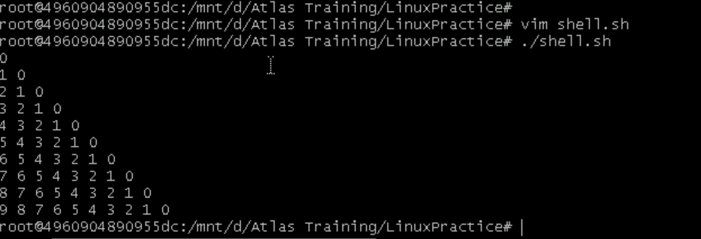

Symbolic links

